 Translated from German to English - www.onlinedoctranslator.com
Vacuum Lifter Switch

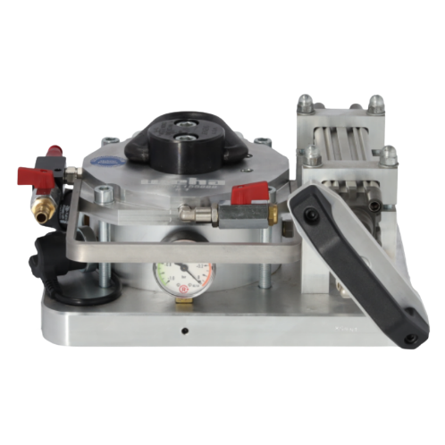


Figure 1Overall View Switch

Description | Vacuum Lifter Switch
Machine / Serial Number | As per delivery note
Year of manufacture
Version | Without suction plate
Load capacity | Depending on the suction plate

COMBINED MASONRY SUPPLIES LTD.
www.masonrysupplies.co.uk

Table of contents
1 Contact 2
2 Declaration of Conformity 2
3 Explanation of Symbols and Warnings Error! Bookmark not defined.
3.1 Warning notices on the vacuum lifter switch 3
3.2 Symbols in the user manual 3
4 Regulations for the use of the Switch vacuum lifter 3
4.1 Application area of ​​the Switch vacuum lifter 3
4.2 Improper use 4
4.3 Safety Instructions 4
4.4 Safety devices of the Switch vacuum lifter 5
4.5 Nameplate 5
4.6 Supply and media feed 5
5 Assembly 5
5.1 Removing the transport packaging 5
5.2 Scope of delivery 6
5.3 Assembly Instructions 6
6 Operating Instructions for the Switch Vacuum Lifter 6
6.1 Preparing the Switch vacuum lifter 6
6.2 Transporting with the Switch vacuum lifter 7
6.2.1 Vacuum lifter switch with compressed air ejector 8
7 Maintenance 8
7.1 Maintenance 8
7.2 Inspection 9
8 Bill of Materials 9

Contact

Please direct your questions or individual part orders to WEHA-Ludwig Werwein GmbH by phone, in writing or by email, or directly to the manufacturer:
In Germany |  | In Austria
WEHA-Ludwig Werwein GmbH |  | WEHA Stone Processing Machinery Sales Company mbH |  | Visit our
Viking Street 15 |  |  |  | Website:
86343 Königsbrunn |  | Long Lane 17
 |  | A-1080 Vienna |  | http://www.weha.com
Telephone:+49 (0) 8231/ 60 07-0 |  | Telephone: +49 (0) 1 / 40 39 340
 |  | Fax: +49 (0) 1 / 40 88 762 |  | Email: info@weha.com
Email: info@weha.com |  | Email: office@weha-wien.at

Declaration of Conformity


The manufacturer / distributor

weha, Ludwig Werwein GmbH
Viking Street 15
86343 Königsbrunn
Telephone: +49 8231 6007-0
Email: Info@weha.com
www.weha.com

hereby declares that the following product

Item number: 155888 + 155890 + 155895
Product name: Vacuum lifter type switch with interchangeable plate system
Use: Lifting / transporting stone slabs
Serial number: as per delivery note / product

This declaration of conformity complies with all relevant provisions of the applicable legal regulations (hereinafter referred to as "the product") – including any amendments thereto in force at the time of this declaration. The manufacturer bears sole responsibility for issuing this declaration of conformity.

The following legal provisions were applied:
Machinery Directive 2006/42/EC

The following harmonized standards were applied:
DIN EN 13155:2022-03

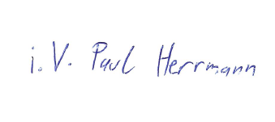
Location: Königsbrunn
Date: February 16, 2026
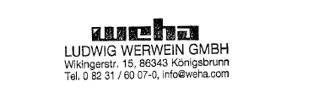

_______________________________

Paul Herrmann
Head of Procurement

The following explanations of symbols that may be present on the device or machine or in the operating instructions are intended to give you an understanding of their meaning

Warning notices on the vacuum lifter switch

The following warning signs may be affixed to the device or machine:

 |  | This warning sign affixed to the machine or device indicates to the operator the presence of operating instructions and obliges him to read them before setting up or commissioning the machine.
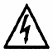 |  | This warning sign on the device or machine alerts the operator to the presence of electrical voltage sufficient to cause an electric shock upon contact with or approach to the hazard. Health or life is at risk at this hazard.
 |  | This warning sign requires the operator of the machine to always wear hearing protection and safety glasses.

Symbols in the user manual

The following symbols may appear in the user manual and are defined as follows:

 |  | An exclamation mark appearing on the pages of these operating instructions, framed by an equilateral triangle, indicates an important notice which the operator should read and follow with particular care.
 |  | A reminder of the obligation to separate waste in order to be able to feed materials into the recycling loop.  Materials can thus be recycled and reintroduced into the manufacturing process, saving resources and reducing the burden on the environment.
D2 |  | Identification of switches, objects, etc. in the illustrations of this operating and user manual

Regulations for the use of the Switch vacuum lifter

Please carefully observe the instructions regarding the use of the machine or device.

Caution: Risk of injury!
Improper use will result in personal injury!

The device or machine is specifically designed for one or more areas of application
The following chapters are intended to explain these possible uses in more detail and to highlight the dangers involved in using the equipment.

Application area of ​​the Switch vacuum lifter

You have purchased a quality product from WEHA-Ludwig Werwein GmbH.

The Switch vacuum lifter is a tool designed to help you move stone slabs and make your work easier.

The following features are particularly noteworthy:
- Easy and quick relocation possible without electricity or compressed air (compressed air optional)
- Robust overall construction
- High lifting capacity with a stone slab
- Visual and audible warning device to signal early the potential fall of the lifting load
- Double-stroke piston pump for fast and convenient vacuum generation

Improper use

The Switch vacuum lifter is intended solely for moving stone slabs

- Use the Switch vacuum lifter exclusively for its intended purposes and refrain from using any means that could damage the metal or individual components!
- The Switch vacuum lifter is complete and specifically designed for the application areas.
- No tools or objects may be inserted between the stone slab and the sealing lip of the SWITCH vacuum lifter.
- Never stop under a suspended load!

Safety Instructions

- Read these operating instructions thoroughly before using the SWITCH vacuum lifter!
- Keep the operating instructions carefully near the SWITCH vacuum lifter, in case of any future doubts!
- Any unauthorized modifications or the installation of additional equipment will void all liability and warranty claims by the dealer or manufacturer!
- Remove all objects from the work area that could pose a potential hazard!
- The SWITCH vacuum lifter may only be operated by authorized personnel. Every operator must have read and understood this documentation.
- Before each use, check the load-bearing parts and welds for damage! If any defects are found, the SWITCH vacuum lifter must be shut down and its use by third parties must be prevented by appropriate measures!
- Check the sealing lip for damage and, if it is damaged, take the device or machine out of service by rendering it unusable and ensuring that it poses no danger to third parties!
- Ensure that the work area has a surface that offers sufficient grip and slip resistance!
- Ensure the warning device's battery is sufficiently charged. Refer to the charger's instruction manual for safety information.
- Make sure you connect the charger with the correct polarity!
- When using a SWITCH vacuum lifter with remote control, there must be no strong electromagnetic fields in the immediate vicinity, for example from mobile phones, garage door remote controls or similar devices!
- Make sure that the surface on which you place the stone slab has sufficient load-bearing capacity!
- Make sure that the sealing lip of the SWITCH vacuum lifter is fully in contact with the stone slab!
- Ensure that the stone slab to be lifted is dust-free and dry in the contact area of ​​the SWITCH vacuum lifter. The surface of the stone slab to be lifted must be smoothly ground in the contact area of ​​the SWITCH vacuum lifter, and furthermore, the stone slab must be flat in this contact area!
- Ensure that the SWITCH vacuum lifter is positioned at the center of gravity of the stone slab! If the stone slab is tilted too steeply, the SWITCH vacuum lifter must be repositioned accordingly!
- Excessive rocking or vibration of the suspended load is not permitted!
- The maximum permissible load can be found on the suction plate, the nameplate or the technical data!
- The maximum permissible load is halved when the SWITCH vacuum lifter is subjected to vertical loading (standing stone slab), see chapter 4.6!
- Only one stone slab may be picked up and transported at a time using the SWITCH vacuum lifter!
- Keep the work area clean and ensure adequate lighting!
- Staying under suspended loads is prohibited!
- Always wear appropriate protective clothing when handling the SWITCH vacuum lifter, in accordance with accident prevention regulations!
- This includes, among other things:
- Work gloves in accordance with accident prevention regulations!
- Footwear must comply with accident prevention regulations!
- Wear hearing protection and safety glasses in accordance with accident prevention regulations!
- Use only workpiece materials suitable for the properties of the device, such as stone slabs without cracks ("sound" stone slabs)!
- Ensure that no one is near the device during use to prevent endangering third parties!
- Check that all parts are correctly assembled!
- If the device is damaged or malfunctions, contact the dealer or manufacturer immediately!
- Protect the device or machine from weather conditions such as rainwater, sunlight, moisture, etc.!
- Should this device or machine no longer be used due to irreparable damage or for other reasons, please ensure that it is taken out of service by rendering it unusable and making sure that it poses no danger to third parties!
- By separating the different materials during disposal, ensure that they can be recycled!

Safety features of the SWITCH vacuum lifter

The SWITCH vacuum lifter was manufactured according to general mechanical engineering standards.
The safety features include:
- The red warning light illuminates when the warning device is switched on and the required vacuum is undershot.
- The acoustic warning signal sounds when the warning device is switched on and the required vacuum is undershot.
- A pressure gauge for constant monitoring of the vacuum during the lifting process.

Nameplate

The type plate provides information about the origin, identity, year of manufacture and, if necessary, the maximum load capacity  Please compare the type plate upon delivery with the information on the first page of the operating instructions. If there are any discrepancies, please contact the dealer or manufacturer immediately. | 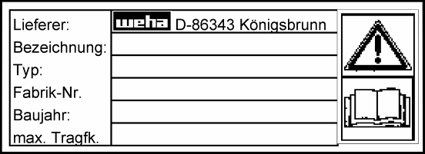

Supply and media feed

Electrical power supply of the charger | 230V / 50Hz
Compressed air supply (optional) | filtered and oiled with an air pressure of up to a maximum of 8.0 bar

Assembly

Please read the information in the Assembly chapter carefully and follow the instructions meticulously. Any damage resulting from failure to comply is excluded from the liability of the manufacturer or WEHA-Ludwig Werwein GmbH

Please inspect the delivered goods for any damage to the shipping packaging. Report any transport damage immediately to the carrier and WEHA!

Any defects caused by incorrect assembly and operation are excluded from the warranty provided by the dealer or manufacturer!

Be sure to observe the safety regulations in chapter0!

Removing the transport packaging

Normally, the SWITCH vacuum lifter is delivered to you packaged in cardboard
Before you begin unpacking, please check the enclosed delivery note for the delivered items!

Removing the transport packaging:

- Detach the adhesive strips or strapping bands and carefully unpack the contents!
- Be careful when unpacking the SWITCH vacuum lifter to avoid damaging it!
- Impact of the SWITCH vacuum lifter components on sharp edges can damage the surface protection and other components!
- Dispose of packaging waste in accordance with local regulations and return it to the recycling loop!

Scope of delivery

Before assembly, be sure to check the scope of delivery to ensure that all necessary parts are included
Contact the retailer or manufacturer immediately if the delivery is incomplete.
Included in the delivery:

- 1 x SWITCH vacuum lifter with charger
- 1 x operating and user manual

Assembly Instructions

The SWITCH vacuum lifter is delivered fully assembled.

No assembly of the individual parts is required

Operating instructions for the SWITCH vacuum lifter

This chapter will familiarize you with the use of the tool. Carefully follow the operating instructions to ensure optimal use of the SWITCH vacuum lifter!

Make sure that the protective coating of the metal parts is not damaged by sharp-edged objects!

Any defects caused by faulty assembly are excluded from the warranty provided by the dealer or manufacturer!

Be sure to observe the safety regulations in section 4.3!

Preparing the SWITCH vacuum lifter

 | Please refer to the following chapter 6.1.2 for instructions on preparing the vacuum lifter!
 | The safety regulations for the charger can be found in the charger's operating instructions!  Ensure correct polarity when connecting the charger to the corresponding warning device!

Before using the SWITCH vacuum lifter, the battery of the warning device must be fully charged.

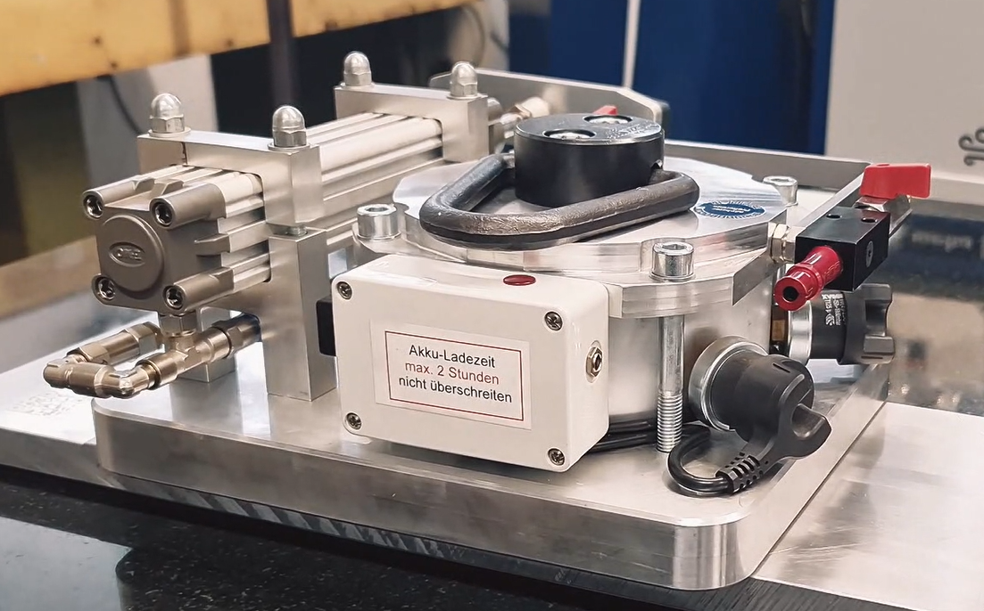  Figure 6.1– Warning device | - Connect the charger to the mains socket 220-230V / 50Hz  - Connect the output cable of the charger to the socket of the warning device to be charged.  - Make sure you connect the charger with the correct polarity!  - Check if the charging indicator light on the charger is illuminated.  - The extinguishing of the charging indicator light signals after some time that the battery is fully charged.  - Unplug the charger from the wall socket and disconnect it from the warning device.

Mounting the suction plate of the SWITCH vacuum lifter

- The suction plate must be purchased separately and is easily mounted using the included Allen screws. Take care not to lose the seals and ensure they are properly installed for a tight seal. The maximum load capacity of the suction plate is printed directly on the plate and applies to horizontal loads; for vertical loads, the stated load capacity is reduced by half.

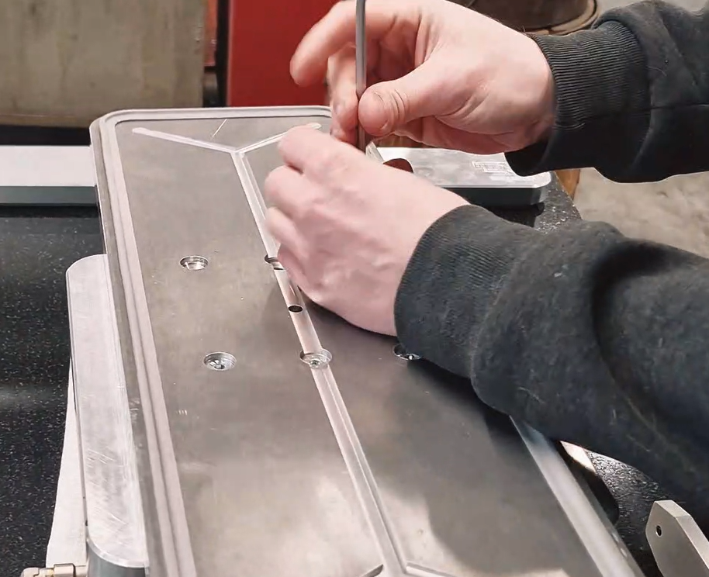

Transport using the SWITCH vacuum lifter

For information on transport using the SWITCH vacuum lifter, please refer to chapter 6.3 below!

- The stone slab to be lifted must be positioned so that it can be transported with the SWITCH vacuum lifter. The suction cup of your SWITCH vacuum lifter must be able to make full contact with the slab. You can find the contact area of ​​your vacuum lifter in the technical specifications.
- The SWITCH vacuum lifter must be placed in the center, at the center of gravity of the stone slab. Refer to the technical specifications for the contact area of ​​your vacuum lifter.
- Ensure that the stone slab to be lifted is dust-free and dry in the contact area of ​​the SWITCH vacuum lifter. The surface of the stone slab to be lifted must be smoothly ground in the contact area of ​​the SWITCH vacuum lifter, and furthermore, the stone slab must be flat in this contact area!
- Now place the SWITCH vacuum lifter on the stone slab to be lifted, in the center at the center of gravity.
- Ensure that the sealing lip of the SWITCH vacuum lifter is fully in contact with the stone slab. Make sure the sealing lip is not twisted during placement and is lying flat.
- Turn the red rocker switch to the left, or in your direction. An audible warning signal will sound and the red light will illuminate. This indicates to the operator that the required vacuum of -0.8 bar is not present. If the vacuum lifter has already been used, there will still be a residual vacuum in the vacuum safety tank. Consequently, the warning signal will not sound and the red light will not illuminate, as the required vacuum may still be present.
- Now operate the pneumatic cylinder by pulling the piston back with the handle and then retracting it forward. Repeat this process until the pressure gauge reads a vacuum of -0.8 bar. Note that a vacuum is created both when extending and retracting the double-stroke piston pump.
- At a vacuum of -0.8 bar, the red light goes out and the acoustic warning signal stops.
- Ensure that there is no loss of vacuum. The pointer on the pressure gauge must not move. If a vacuum loss occurs, the stone slab cannot be transported. The sealing lip and the contact surface must be checked, and a vacuum must be created again. If the attempt fails again, the SWITCH vacuum lifter must be inspected to ensure it is in perfect working order.
- The shackle is now used to connect the SWITCH vacuum lifter to the lifting device.
- Ensure that the suction plate and lifting device used have the required load-bearing capacity to support and transport the entire load. Refer to the technical specifications to ensure that the permissible load capacity of your lifting device is not exceeded. Please also note that the permissible load capacity is halved when transporting stone slabs vertically.
- Now lift the SWITCH vacuum lifter with the lifting device until the stone slab is hanging freely.
- Now make sure that the stone slab is hanging as horizontally as possible. If the stone slab is tilted, the SWITCH vacuum lifter must be repositioned accordingly, otherwise the stone slab will detach from the SWITCH vacuum lifter!

- Now the stone slab can be lifted to transport height.
- No vibrations may occur during transport, and the stone slab must not swing.

Danger!
If the audible warning signal sounds or the red light illuminates during transport, the stone slab must be set down immediately!
In an emergency, the vacuum can be temporarily restored by reactivating the pneumatic cylinder; however, the danger zone must not be entered!

- Make sure that the surface on which you are placing the stone slab has sufficient load-bearing capacity!
- Once the stone slab is in place and secured, the blue ring of the manual slide valve must be pushed back to the left. The vacuum chamber is now vented, and the vacuum safety tank retains its vacuum.
- The SWITCH vacuum lifter can now be lifted off the stone slab.

SWITCH vacuum lifter with pneumatic ejector

- The compressed air ejector is installed as standard on the SWITCH vacuum lifter!

Figure 6.5- SWITCH vacuum lifter with ejector  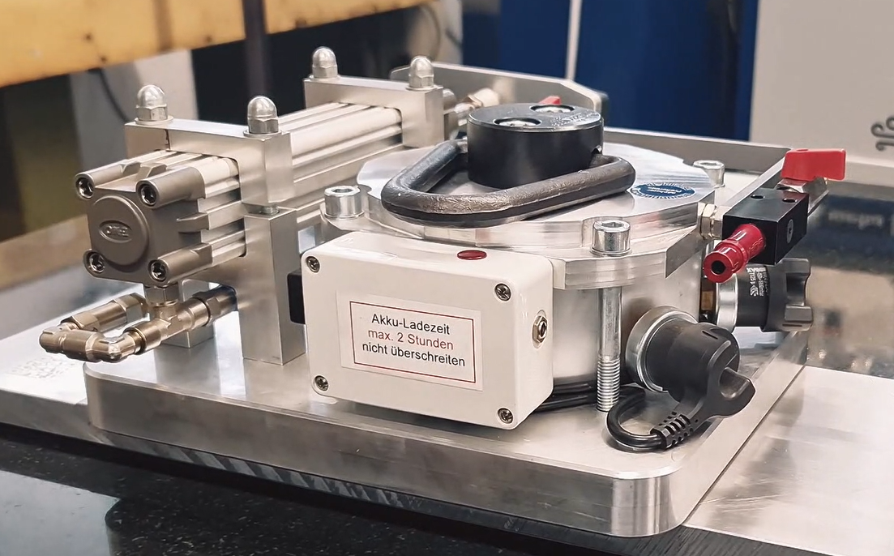 | - The pneumatic cylinder is complemented by the compressed air ejector. The vacuum can therefore also be generated via the compressed air ejector  - To use the compressed air ejector, first connect the compressed air supply to the compressed air nipple. The air pressure must not exceed 6.0 bar.  - Instead of the instruction "Now actuate the pneumatic cylinder, ...", the vacuum is now created by opening the rocker arm in the direction of the arrow.  - The current vacuum level is displayed on the manometer.  - Once a vacuum of -0.8 bar is reached on the pressure gauge, the manual valve must be closed counterclockwise. Creating the vacuum takes approximately 1 minute if the vacuum safety tank has not already created the vacuum.

Danger!
If the acoustic warning signal sounds or the red indicator light [C6] flashes during transport, the stone slab must be set down immediately!
If a vacuum loss occurs, the vacuum pump is immediately switched on to counteract the vacuum loss!

- Make sure that the surface on which you are placing the stone slab has sufficient load-bearing capacity!

Maintenance

The following are the tasks that the operator of the SWITCH vacuum lifter must have carried out by a person with the appropriate expertise!
The manufacturer is not liable for damages resulting from failure to follow these instructions!

Maintenance

The SWITCH vacuum lifter requires regular maintenance.

- The sealing lip of your vacuum lifter must be cleaned and checked for damage monthly

Inspection

Figure 7.1Inspection sticker

- The SWITCH vacuum lifter is a lifting device! The employer using the SWITCH vacuum lifter must ensure that it is inspected by a qualified person at intervals of no more than one year! (§ 40, para. 1, VBG 9a)
- The next inspection date for the SWITCH vacuum lifter is indicated on the yellow "next inspection date" sticker. (e.g., in April 2015)
- Repairs and welding (risk of poisoning!) may only be carried out by persons who have the necessary knowledge and skills!

- You can have your SWITCH vacuum lifter inspected by a qualified expert at WEHA-Ludwig Werwein GmbH in Königsbrunn, just ask us!

Pay attention to the safety regulations in Chapter 3.3!

This inspection must be carried out at least once a year.

- Check the SWITCH vacuum lifter once a year for rust spots, especially all welds.
- Remove the rust and protect the area by applying a suitable rust inhibitor, e.g., zinc spray.
- Check all screws of the SWITCH vacuum lifter for looseness and tighten them if necessary.
- Check the rubber sealing lip for damage and have it replaced if necessary, either by the dealer or
Manufacturer.

Repairs and welding (risk of poisoning!) may only be carried out by persons who have the necessary knowledge and skills!

Bill of Materials

When ordering, specify quantity, part name, item number and, if applicable, the standard abbreviation

Repairs may only be carried out by the manufacturer!
Unauthorized repairs or the installation of additional equipment will void any liability and warranty claims by the dealer or manufacturer!

