Stone Slab Storage Equipment
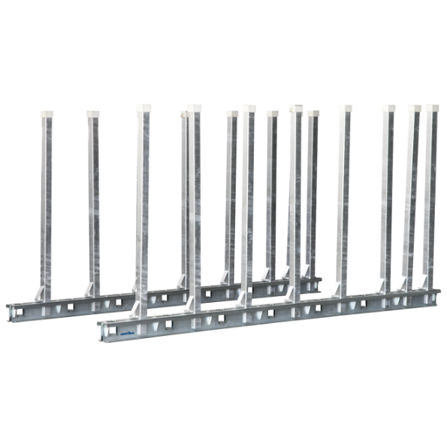
Description | Stone Slap Storage Equipment
Type | Hippo Bundle Rack Set  Buffalo Slap Rack  Bison Slap Rack
Article Number
Serial number
Manufacturing year

Table of contents
1 Machine Identification Plate 1
2 Assembly 1
2.1 Scope of Supply 2
2.2 Assembly instructions 2
3 Loading 3
3.1 Carrying capacity 3
4 Safety regulations 4
5 Maintenance and inspection 5
6 List of spare parts 5
7 Declaration of conformity 6
8 Contact 6

1 Machine Identification Plate

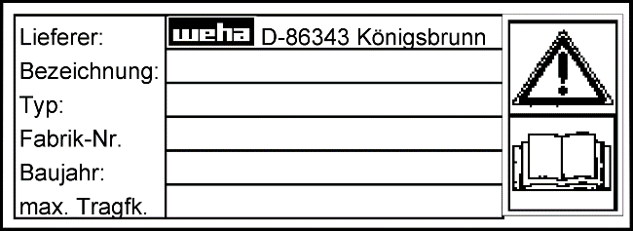
The type plate provides information about the origin, identity, year of manufacture and, if necessary, the maximum carrying capacity. On delivery, please compare the type plate with the information on the first page of the operating instructions. If data differ, please contact the dealer or the manufacturer immediately.

2 Assembly

Before installing and using the support stand, read the operating instructions carefully and follow the them precisely. Possible damages due to disregard are excluded from the liability of the manufacturer or WEHA-Ludwig Werwein GmbH.

2.1 Scope of Supply

Check the delivered goods for damage. Damages caused by transport must be reported immediately to the dealer and the WEHA company. Also check if all parts are present.
The scope of supply consists of:
- 2 x perforated rails
- 20 x iron tubes (RR); 16x iron tubes (Magnum / Bison / IRAXX)
- 1 x operation manual

2.2 Assembly instructions

The support stand must be assembled.
When unpacking, transporting and assembling, take care not to damage the galvanized metal parts with sharp-edged objects.
The panel stand can be mounted without the use of special tools.
In principle, the support stand is mounted as follows:
- Place the rails directly on the ground parallelly to each other.
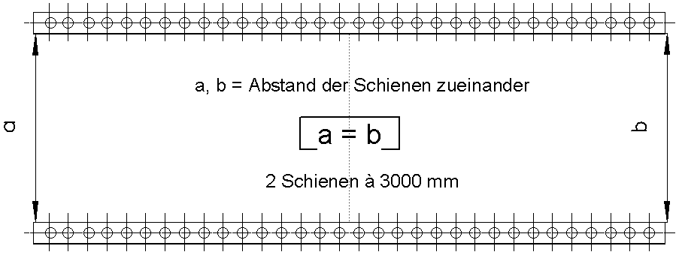
2 rails 3000mm each
a, b = Distance of the rails to each other
- Insert the iron tubes into the holes.
IT IS IMPERATIVE TO FOLLOW:
- The ground must be horizontal, level and firm. Make sure of this with a spirit level and a shaking the tubes.
- The rails must always run parallel, i.e. have the same distance to each other over the entire length of the support stand.
- Select the distance between the outer sides of the rails in such a way that it equals the width of the panels to be stored, in order to avoid the stand tipping over sideways.
- Distribute the tubes equally on both sides, i.e. 10 or 8 tubes per perforated rail. All tubes supplied must be inserted.
- Distribute the tubes in such a way that they are inserted in the same holes in both perforated rails, i.e. if they occupy holes 1, 4, 7 and 10 in rail 1, for example, they must also occupy holes 1, 4, 7 and 10 in rail 2. Never insert the tubes into the rails offset to each other.
- Make sure that the tubes are fully inserted into the holes.
- Always check that all tubes are in perfect working condition and that no deformations or cracks are visible.

3 Loading

IT IS IMPERATIVE TO FOLLOW:
- Always load the support stand evenly from the center over the entire area in use.
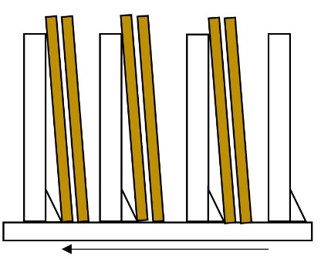
          - Always load the plate stand so that the plates are leaned in the direction of the small angles at the bottom of the tubes.
Exception: trapezoidal support. This must be loaded equally from the left and right.
          - The only function of the angles is to ensure a minimum distance between the slab and the tube in order to achieve an ideal load on the tubes.
Direction of inclination

- Make sure that the tube in rail A and the corresponding tube in rail B are equally loaded by the plate. This is guaranteed if the supporting edge of the plate is exactly perpendicular to the two rails.

- Avoid knocks and bumps against the tubes. Lean the slabs against the tubes cautiously and with a suitable lifting tool.

3.1 Carrying capacity

Always lean the slabs against the tubes as steeply as possible. Make sure that you do not exceed the maximum allowed distance from the following table. This distance depends on the panel thickness.
d

d: Thickness of plate
h: Height of the slab
r: Height of the tubes
a: max. Distance between slab and tube
h

r

a

RR
r = 1 m |  | r = 1.5 m
d[cm] | a[cm] | d[cm] | a[cm]
9 | 17.6 | 4.5 | 54.6
17 | 8.8 | 6 | 40.2
29 | 5.2 | 8.9 | 26.5
 |  | 17.7 | 13.1
 |  | 29.4 | 7.9
The following tables are only valid for a slab height h of up to 2m.
Bison
r = 1.5 m
d[cm] | a[cm]
18 | 14
22 | 12
26 | 10
32 | 8
42 | 6
MAGNUM
r = 1.2 m |  | r = 1.5 m
d[cm] | a[cm] | d[cm] | a[cm]
13 | 20 | 9 | 25
16 | 16 | 11 | 20
22 | 12 | 15 | 15
26 | 10 | 18 | 10
33 | 8 | 22 | 8

IRAXX
r = 1.5 m
d[cm] | a[cm]
22 | 16
24 | 14
27 | 12
31 | 10
36 | 8
44 | 6
Trapezoidal support
d[cm] | a[cm]
30 | 50.9
58 | 24.6
190 | 7.3
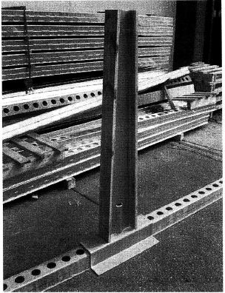
Option trapezoidal support: (valid for h = 1.8 m)

(Load this support from both sides)

4 Safety regulations

- Before using this slab stand, read the operation manual thoroughly.
- Keep this manual in close proximity of the stone slab.
- The dealer or manufacturer will not be liable for any damage caused by unauthorized modifications or the installation of additional equipment.
- Remove all objects from the working area that could be a potential source of danger.
- Make sure that the surface on which you set up the slab stand is horizontal or level, has the necessary stability and has a load-bearing capacity corresponding to the weight to be lifted.
- Keep the storage area clean and provide adequate lighting.
- The slab stand may only be operated by authorized persons. Every operator must have read and understood this documentation.
- Check the load-bearing parts and welds for damage before each use. If defects are found, stop the operation of the plate stand and take appropriate measures to prevent its use by third parties.
- Ensure a non-slippery surface in the working area
- Do not stand under suspended loads.
- Always wear appropriate protective clothing when handling the slab stand. This includes suitable work gloves and footwear in accordance with accident prevention regulations.
- Only use workpiece materials suitable for the properties of the unit, such as stone slabs without cracks ("healthy" stone slabs).
- Ensure that no one is near the unit during operation to avoid endangering third parties.
- Check if all parts are correctly assembled.
- If any damage or malfunction occurs to the unit, contact the dealer or manufacturer immediately.
- Protect the device or machine from weather conditions such as rainwater, sunlight, moisture, etc.

5 Maintenance and inspection

The slab stand requires regular maintenance.
According to ZH 1/428, this is a storage device that must be checked by an expert regularly.
The following inspection must be carried out at least once a year:
- Check the slab stand for rust. Pay special attention to the welding seams.
- Remove possible rust and protect the relevant areas by applying a suitable rust protection agent, e.g. zinc spray.

6 List of spare parts
Quantity | Designation | Article number
2 | Perforated rail galvanized | 104610
20 | Iron tube galvanized | 104611
Slab Stand RR with tube length 1 meter.

Article number: 104741

Quantity | Designation | Article number
2 | Perforated rail galvanized | 104610
20 | Iron tube galvanized | 104612
Slab Stand RR with tube length 1.5 meter.

Article number: 104742

Quantity | Designation | Article number
2 | Perforated rail galvanized | 115158
20 | Iron tube galvanized | 115160
Slab Stand Bison with tube length 1.5 meter.

Article number: 115161

Quantity | Designation | Article number
2 | Perforated rail galvanized | 108588
16 | Iron tube galvanized | 107418
Slab Stand MAGNUM with tube length 1.2 meter.

Article number: 108590

Quantity | Designation | Article number
2 | Perforated rail galvanized | 108588
16 | Iron tube galvanized | 108589
Slab Stand MAGNUM with tube length 1.5 meter.

Article number: 107419

Quantity | Designation | Article number
2 | Perforated rail galvanized | 137326
16 | Iron tube galvanized | 137327
Slab Stand IRAXX with tube length 1.5 meter.

Article number: 137328

7 Declaration of conformity

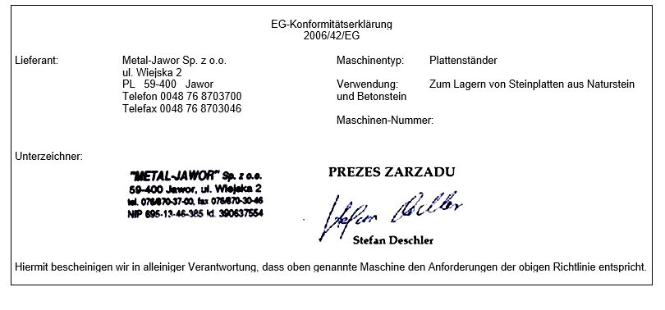

8 Contact

Please address questions or individual part orders by telephone, in writing or by e-mail to WEHA-Ludwig Werwein GmbH.
Germany | Austria
WEHA-Ludwig Werwein GmbH | WEHA Steinbearbeitungsmaschinenvertriebsgesellschaft m.b.H.
Post box 13 55  86331 Königsbrunn / Augsburg  Wikingerstraße 15  86343 Königsbrunn / Augsburg | Lange Gasse 17  A-1080 Wien
Phone: +49 (0) 8231 / 60 07-0  Telefax: +49 (0) 8231 / 60 07-148  E-Mail: info@weha.com | Phone: +49 (0) 1 / 40 39 340  Telefax: +49 (0) 1 / 40 88 762  E-Mail: office.weha@aon.at
Visit our website:
http://www.weha.com

